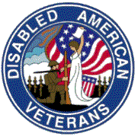 | Disabled American Veterans, Department of Maryland,Inc.  Newsletter | Tel # 410-539-1310  Fax # 410-539-2106  Email Address: dav_md@verizon.net  Mid-Winter Conference  January 10-12, 2008  Princess Royale Hotel & Conference Center  9100 Coastal Hwy.  Ocean City, MD 21842  Tele # 1-800-476-9253 or 410-524-7777  Year 2007-08 Issue 2  Dated: December 2007  Publisher: B. Iafolla

DAV, Department of

Commander Message:

I bring you greetings and wish everyone a happy and joyous holiday season. We pray for peace and the elimination of hunger and suffering everywhere. Our mission of making the lives of veterans and their families better is never ending. Although much work has been done, there is much more to be done. I owe each of you a big thank you for what you do in a spirit of giving. I am particularly grateful to all of our volunteers. Also appreciative of the work done by the hospital service coordinators, drivers, and national, department and chapter service officers for all of the long hours they spend helping veterans with everything from claims and transportation to VA medical centers and clinics. Although short staffed those serving in the positions of hospital service coordinators and on the Hospital and Rehabilitation Commission have done an enormous job. Again, we are eternally grateful.
No matter the problem we will not rest until all veteran get the benefits they have earned. There are never enough volunteers; pass the word. Accordingly, I plead with all of you to volunteer, step up and lend a helping hand.

The 2nd Department Executive Committee, during the Mid-Winter Conference, is scheduled to be held in January 2008; this denotes that the membership year will be at the half way mark. We will continue to work hard to exceed the membership goals we are charged to achieve. Looking at the committees, we expect each person assigned to a committee to roll up their sleeves and make a positive effort by doing those things required to accomplish the mission of DAV and this Department.

Sincerely,

Glynn E. Parker
Commander
DAV, Dept. of Maryland

IMPORTANT PHONE NUMBERS

Nat’l. Hdqrs., DAV (877)426-2838
DAV, Dept. of MD (410)539-1310
(800)328-6953
NSO Office – Baltimore (410)230-4440
NSO Office –Wash., DC (202)530-9261
VA Regional Office –Balto. (410)230-4500
(800)827-1000
VA Regional Office – DC (202)530-9260
Dept. of Veterans Affairs (800)446-4926
VAMHCS – Baltimore 1-800-463-6295
DAV Transportation (410)605-7000
HSC, Toni King (Ext. 6733)
BRECC (410)605-7000
VAMHCS – Perry Point 1-800-949-1003
DAV Transportation (410)642-2411
HSC, George W. Mitchell (Ext. 5384)
VAMC – Cambridge (410)228-6243
VAMC – Cumberland (301)724-0061
VAMC - Fort Howard 1-800-351-8387
DAV Transportation (410)477-7050
HSC, (Ext. 7019)
VAMC – Greenbelt (301)345-2463
VAMC – Loch Raven 1-800-463-6295
VAMC – Charlotte Hall (301)884-7102
1-800-522-8387
VAMC – Hagerstown (301)665-1462
VAMC – Glen Burnie
DAV Transportation (410)590-4140
HSC, Tommie Hawkins (Ext. 4221)
VAMC – Pocomoke 1-877-864-9611
VAMC – Washington, DC (202)745-8100
VAMC - Wilmington, DE (302)633-5414
VAMC – Martinsburg, WV (304)263-0811

Telephone Care Line: To schedule Urgent Care Appt. call 1-800-865-2441
Prescription Refill Line: 1-800-463-6295, ext 7395
Have SS# & Prescription # ready, press option “2”
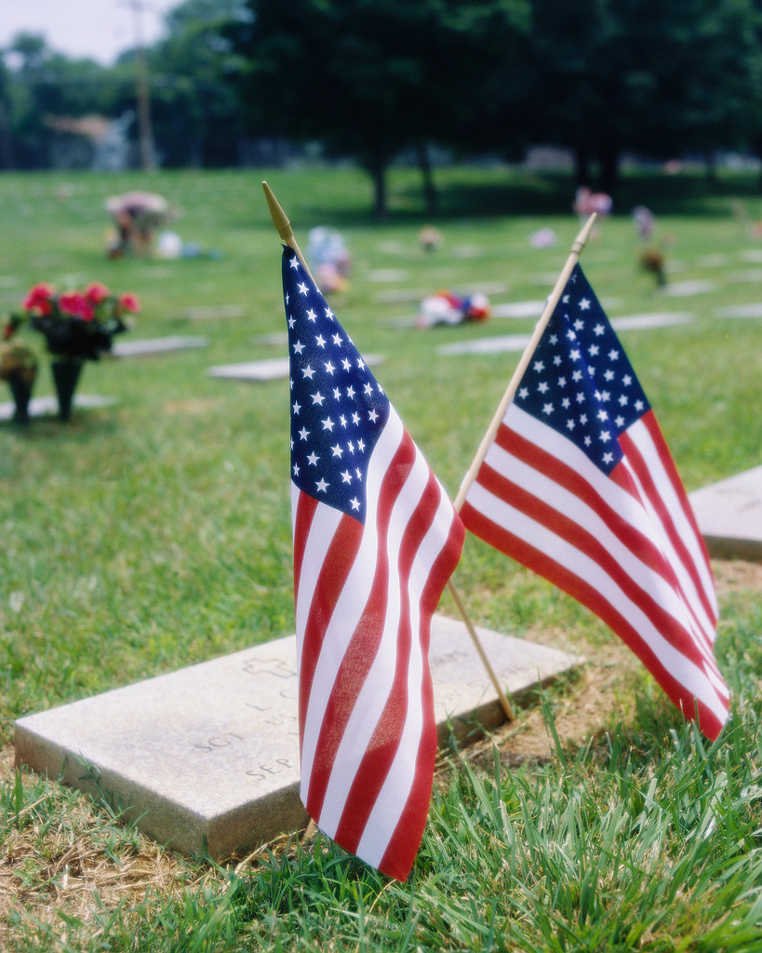
CEMETERY & MEMORIAL PROGRAMS
Robert L. Hooper III, Director
1122 Sunrise Beach Road
Crownsville, MD 21032
Anne Arundel County
410-923-6981

CHELTENHAM VETERANS CEMETERY
Martin F. Fahey, Superintendent
Cheltenham
Prince George’s County
301-372-6398

CROWNSVILLE VETERANS CEMETERY
Christopher T. Piscitelli
Superintendent
Crownsville
Anne Arundel County
410-987-6320

EASTERN SHORE VETERANS CEMETERY
Bruce W. Webster, Superintendent
Hurlock
Dorchester County
410-943-3420
Toll Free – 866-497-3684

GARRISON FOREST
VETERANS CEMETERY
Kenneth McKisset, Superintendent
Owings Mills
Baltimore County
410-363-6090

ROCKY GAP VETERANS CEMETERY
Ronald B. Platt, Superintendent
Allegany County
301-777-2185

MEMORIALS
Patrick M. Tracy, Superintendent
Baltimore, MD
410-354-3550

WAR MEMORIAL BUILDING
(WWI & II records, service metals)
Douglas W. Henley
Executive Director
Baltimore
410-396-8013
UPCOMING EVENTS
(DATES TO REMEMBER)
December, 2007

In December – Toys for Tots
Sponsored by the Marine Corps League, DAV, American Legion & VFW
Bring your NEW UNWRAPPED TOY to the DAV Chapter #7 Home and drop it off between Noon and 10 PM – LAST CALL FOR TOYS IS FRIDAY, DECEMBER 14TH.

1 Flag Raising in remembrance of Pearl Harbor

5 DAV/DAVA #26 Meeting, 7 p.m. &
Christmas Party & Raffle Ticket Drawing
VFW Post 2632
23282 Three Notch Road
California, MD 20619

6 DAV/DAVA #13 Christmas Party 6PM
8200 Old Quarterfield Road
Severn, MD 21144

7 DAV/DAVA # 34 Christmas Party 7:00
Golden Corral
301 East Naylor Mill Road
Salisbury, MD 21804

10 DAV/DAVA # 3 Christmas Party 6:00 PM
Annapolis Elks Lodge
2517 Solomons Island Road
Annapolis, MD 21401

11 DAV Chapter #33 Christmas Party 7:30 PM
Western District Police Station (MD170)
Odenton, MD (Pot Luck)

12 DAV/DAVA #4 Christmas Party 6:30 PM
VFW, Post 2562
11316 Fern Street
Wheaton, MD 20902

13 DAV/DAVA #01 Christmas Party 7PM
Fifth Regiment Armory
219 W. Hoffman St.
Baltimore, MD 21201

DAV/DAVA #21 Christmas Party 7:PM
American Legion Post 38
Dundalk Avenue
Dundalk, MD

15 DAV/DAVA #7 Children’s Christmas Party
Disney Bell Post #66
American Legion in Bowie 2:00-4:00 PM

18 DAV/DAVA #22 Christmas Party 6:30PM
VFW Post 467
519 Poole Road
Westminster, MD 21157

20 DAV #5 Christmas Party 7PM
Amvets Post #2
702 E. South Street
Frederick, MD 21701

DAV #36 Christmas Party 6:00 PM
Greater Waldorf Jaycees Ctr.
3090 Crain Hwy.
Waldorf, MD 20601

24 DAV/DAVA #7 (2PM – 6PM)
Open House (Light refreshments – No Christmas Party)
8205 Laurel Bowie Road
Bowie, MD 20715

25 Christmas

26 Kwanzaa Begins

January, 2008

10-12 Mid-Winter Conference – Ocean City
17-20 NEC 6th District Mid-Year Conf. Cruise

February, 2008
6 Ash Wednesday
12 Lincoln’s Birthday
14 Valentine’s Day
18 Presidents’ Day
22 Washington’s Birthday

MARK YOUR CALENDARS

Mid-Winter Conference (DAV/DAVA)

January 10-12, 2007
Princess Royale Hotel & Conference Center
9100 Coastal Highway
Ocean City, MD 21842-2745
Tele: 1-800-476-9253 or 410-524-2544

All Reservations must be made NLT December 22, 2007. The room rates are $64.00 per night for Poolside and Ocean view. To make your reservations, please call the Princess Royale Reservation desk at 1-800- 476-9253 or 410-524-2544. Note: Call the Hotel if you do not received your confirmation.

All DEC Reports are due in the Dept. Office NLT 12/21/07. You may send them by fax 410-539-2106 or email to dav_md@verizon.net .

Dept. Adjutant – Lisa M. Gregory

Greetings to all,

The Holiday season is upon us and I encourage everyone to take this opportunity to visit other chapters during this time. There are many opportunities for us to share ideas and create new ways to enhance what we do in Maryland. The Department staff can give you more information if you would like to attend a holiday function in your area.

This is also a great time of year to promote the DAV by making a presence within our own communities. Many of us volunteer with other organizations and we can use that as a way to branch out to other veterans. When you're out and about this season wear your cap or some other item that designates you as a member of the DAV. Also, many of our chapters are located near military installations or National Guard armories so let's not forget the families that may have a holiday without a loved one at home. We should also take time to get out and visit our sick and shut in members. Let them know they are still a vital part of your chapter. It's a busy season for all of us, but let's not forget those who need our help the most, the veterans of this state.

And of course as the Adjutant I will again remind everyone of the importance of working with the Department if you should have issues come up in your area. We are here to serve you and many times can easily resolve a problem with a simple phone call.

I also want to thank all of the chapters who turned in their reports in a timely manner. It's important to get the paperwork out of the way so we can focus on what needs to be done.

Have a great Holiday Season and See you all at Mid-Winter!!!

Lisa Gregory
Adjutant



Dept of Maryland – Admin Asst
(Cookie) B. Iafolla

- Department Website: Check it out at
davmembersportal.org/md.
If you notice any discrepancies please contact the Department Office at 410-539-1310.

- Please call the Department if you know of any Sick hospitalized/Rehab, or deceased member, because we would like to mail out cards to them or their family.

- Have you given the Department your current email address – we would like to keep you informed, so if you have email or your email address has changed, please contact the office at 410-539-1310 or dav_md@verizon.net.

AND

Dept. SVC – Gregory N. Jones

Happy holidays to all. As we transition through and celebrate during the upcoming holiday season, let us always be mindful of the troops that are in harms way. Please keep them in your thoughts and those who believe in a divine power, pray for the safe return of each and every one of our sons and daughters. I attended the following meetings:

10/13/2007
Attended VA, Department of Virginia - 75th Anniversary Celebration
Hampton, VA.

10/17/2007
The MD Joint Veterans Committee of Maryland Meeting at the Baltimore Detachment, Marine Corps League in Baltimore, MD

10/21/2007
The First 2007-2008 DEC, Department of Maryland

11/11/2007
The Veterans Day Ceremony at Arlington Cemetery.

The following is a list of my planned visited for the month of December. The Commander created this list and I asked if I could accompany him on some of these visitations. This list has been modified. The Commander will probably attend more chapters and other meeting than I have listed here. For those of you who I am not able to visit during this holiday season, please know that my thoughts are with you, I plan to see you soon.

DECEMBER 2007 PLANNED VISITATIONS

Organization | Date | Address | Time
Chapter 26 | December 5 | St. Mary’s  VFW Post 2632  23282 Three Notch Road  California, MD 20619 | 7:00 PM
Chapter 13 | December 6 | 8200 Old Quarterfield Road  Severn, MD 21144 | 6:00 PM
Chapter 34 | December 7 | Golden Corral  301 East Naylor Mill Road  Salisbury, MD 21804 | 7:00 PM
Chapter 7  SVC Gregory Jones to attend. | December 7 | Omaha Beach  8205 Laurel Bowie Road  Bowie, MD 20715
Chapter 3 | December 10 | L. L. Merrill, Sr.  Annapolis Elks Lodge  2517 Solomons Island Road  Annapolis, MD 21401 | 6:00 PM
Chapter 33 | December 11 | M. R. “Sarge” Warehime  AA County Police Station  MD Route 170  Odenton, MD 21113 | 7:00 PM
Chapter/Unit 4  * bring wrapped toy | December 12 | Ernie Pyle  VFW Post # 2562  11316 Fern St.  Wheaton, MD 20902 | 6:00 PM
Chapter 1 | December 13 | Paul L. Thompson  Fifth Regiment Armory  219 W. Hoffman St.  Baltimore, MD 21201 | 7:00 PM
Chapter/Unit 21 | December 13 | American Legion Post 38  Dundalk Avenue  Dundalk, MD | 7:00 PM

DAV Dept. of Maryland | December 17 | War Memorial Bldg  101 N. Gay Street  Baltimore, MD 21202 | 12:00 PM
Chapter 22 | December 18 | Old Glory  VFW Post #467  519 Poole Rd.  Westminster, MD 21157 | 6:00 PM
Chapter 36 | December 20 | PFC De Marr  Greater Waldorf Jaycees Ctr.  3090 Crain Hwy  Waldorf, MD 20601 | 6:00 PM

God bless you all and please have a safe and happy holiday season.
Gregory Jones
Senior Vice Commander

1ST JVC – Robert L. Wilcoxen

First of all, I hope everyone had a SAFE Thanksgiving Holiday and are staying well (not overeating). I also would like to wish all of the Comrades in the Department of Maryland and Auxiliary a HAPPY and SAFE holiday season.

I am sorry I couldn’t attend the National Convention in New Orleans; however I did make the DAVA Fall Conference in Kentucky. This gave me a better understanding of how their program works.

I plan tosend a letters to the Chapters listed below of my intended visits for the second half of the 2007-2008 membership year. If for some reason your chapter is unable to meet on the dates listed, please let the Department or me know ASAP. It’s a long drive from Lexington Park, MD to a chapter for a visit and not one member is there. My home phone numbers is 240-895-0058 or email me at robertwilcoxen@verizon.net.

Chapter #7 8 January 08
Chapter #17 22 January 08
Chapter #26 6 February 08
Chapter #36 21 February 08
Chapter #3 3 March 08
Chapter #23 13 March 08
Chapter #4 4 April 08

I would like to thank all of the Chapters that I visited for the informative they provided and the way they conduct their meetings. This has enabled me to gain a better knowledge of the programs with which they are working. I look forward to seeing all of our Comrades in the upcoming Months and at the Mid-Winter Conference/DEC in Ocean City, at the Princess Royale Hotel, January 10 – 12.
Happy Holidays to All,
Bob L. Wilcoxen


4th JVC – Flip Micocci__

Greetings comrades,

Since becoming the 4th Jr. Vice Commander, I have been able to attend some functions at various chapters. I have a unique advantage due to being a “Blue Hat” and a NSO. When I visit a location pertaining to NSO duties, I am able to speak with members of the local Chapter and discuss matters pertaining to State DAV issues.

November was a busy month. On the 7th I attended a Chapter 26 seminar. This event was a great success due to excellent preparation by the Chapter members. 1st Jr. Vice Commander Wilcoxen was present at this event and it was easy to see that his leadership, along with acting Chapter Commander Boles, and PDC Myers, contributed to the success of this seminar. Added support came from Auxiliary Commander Swift, Adjutant Simmons, and 1st Jr. Vice Commander Wilcoxen. This Chapter has excellent CSO’s and fully supports any Chapter outreach, through the state or through the National Office. State Commander Parker also showed up and spoke at this event.

I also visited Chapter 14 for an open seminar. Commander Hansen and Adjutant Unger were there to welcome me and help with the meeting. I had a meal with the Commander and the Adjutant, and we discussed CSO responsibilities and future visits. The Chapter there seems to be doing well.

This next quarter I plan to visit two more chapters, and of course supporting the Commander in any way I may be able to. In my travels, I will always make sure I spread the word about what the DAV can do to help our veterans, on a state and national level.

Season Greetings to All,
Flip P. Micocci

Message from Dept. Chaplain:
Alfreda M. Alexander

God’s blessing for the holidays

Winter’s chill is in the air and veterans everywhere are getting ready for the upcoming holiday season. Some are using spare time to purchase presents for their loved ones, some are making travel arrangements, some are “eating” their way into the spirit and some are all alone. Even though this is usually a very festive time of year for most, some of our fellow comrades are “troubled” by all the hustle and bustle.

Many are in hospitals, many are waiting on their next check, and many are homeless and wondering what so “merry” about their particular situation. I ask that you join me in saying a prayer for all of our veterans this year . . . pray that they will be at peace and find comfort with family and friends. Pray that each one enjoys a happy holiday season and that each one is blessed with good health and a prosperous New Year.

If you have the chance to be a blessing to someone this holiday season, I pray that you will. Sometimes, all it takes is a smile and a kind word to make a monumental difference in someone else’s life. If so inclined, visit veterans in the nearby hospital and let them know that you are grateful for their sacrifices.

My prayer is that all veterans will realize just how blessed they are. Have a wonderful blessed holiday season and a prosperous New Year.

Peace be with you all,

Alfreda M. Alexander

Please

Let

There

Be

On

EARTH

NOW…

FOR THOSE WHO ARE ILL, IN HOSPITALS OR RECOVERING FROM AN ILLESS OR SURGERY, YOU ARE IN OUR THOUGHTS & PRAYERS…

PDC (Bill) Wilfred C. Meyers, Chapter 7
Toni King, Chapter 7 (HSC-Baltimore)
John H. Wells, Chapter 16
Hazel Meyers, Unit 17
Lucy Johnson, Unit 17
Nellie Childress, Unit 26
Thomas R. Dennee, Chapter 26
Polly & Terry Singer, Chapter 26
Rosa Lee Gutzer, Unit 26
Alice & Vincent Thrasher, Chapter/Unit 26
John Slaten (Cmdr. Chapter 28)

And to all the other DAV/DAVA Members who are not listed above that is ill, or who was hospitalized and is in the recovery stage,

GET WELL SOON,
THE DAV/DAVA NEEDS YOU…

“May our Comrades and Friends
Rest In Peace”
YEAR 2007-2008

Chapter # 03 Eugene B. Flickey
James M. Rains
Harry Tanouye
Charles Dennis
Solomon Cooper
Eugene F. Shine Jr.
James Ingram
Unit # 7 Dottie A. Twohig
Chapter # 16 Leonard R. Rencher (Dept. Adj.)
Unit # 17 Betty T. Thomas
Chapter # 21 Arthur Hancock
Kenneth H. Avaritt
Chapter #22 Lee E. Griffee
Roy E. Heaney
Francis R. Hoare
Clarence J. Zerrlaut
Unit # 26 Hilda T. Wolfram
Chapter #30 Charles O. Fruhling
Chapter #34 Walter W. Fisher
Harold S. Shiles
Chapter #36 Russell T. Hamilton

“Heavenly Father, in your hands is the souls of the living and the dead. We pray that you will give your healing to those who are ill and that the souls of our departed comrades are with you in the place you have prepared for them, lift up the hearts of those burdened with sorrow and grant them Peace.”
Amen….

DEPARTMENT COMMITTEES:

Legislative Committee
Chair - PDC Ernest Law

Look at all the Legislative bills that are of concern to the Veterans in the State of Maryland, and do the following:

Go to the Rally’s, write letters, make calls and voice your opinions to your Legislators, and make them listen to you. Let your voice be heard by those who are making the decisions that concern all the veterans.

To build better lives for Veterans & their families, we need a Legislative Body who feels the same way as we do! Do you know how your Legislators are voting on Veteran Issues? If not –
GET INVOLVED!

Maryland Service Foundation
President: PDC Howard L. Simons Jr.

We are planning to hold the next MSF meeting at the Mid-Winter Conference in Ocean City, MD in January. Date and Time of meeting will be posted at Registration. Everyone is invited to attend this meeting.

Membership Committee
Chair - SVC Gregory N. Jones

During the recent Department Executive Meeting held on October 21, 2007, questions were raised concerning “Trial” memberships. After some research and an inquiry to DAV National Headquarters, Department Commander Glynn E. Parker, in a memorandum dated November 15, 2007, responds to those questions. Please refer to his memorandum addressed to “All Chapters, Department Staff, and PDC dated November 15, 2007.

The Department of Maryland is in DAV’s Division II membership category – 18,000 to 34,000 members. We are currently in the seventh position. There are 16 other states in Division II. As of 12/3/07, our total membership is 18,212 of which 15,408 are full paid life members. Last year’s total membership was 19,223.

According to the current DAV National Membership Department Reports dated 12/3/07, we are 284 members short of the projected goals for the current membership year. According to these reports our top three Department of Maryland recruiters are as follows:

First Place: Paul Sydorko
Second Place: Ron Minter
Third Place: David Souter

Good job and keep up the good work.

Considering the current reports, there is lots of work to be done. So, please let us double our efforts and get out there and sign up those members.
Neither a wise nor a brave man lies down on the track of history to wait for the train of the future to run over him.

“The Greeks believe that when a man had too much power for his own good, the gods ruined him by helping him increase his power at the expense of wisdom… and humanity, until it led automatically to his own destruction.”

◊ Thomas Merton

Thomas Merton (January 31, 1915 – December 10, 1968) was one of the most influential Catholic authors of the 20th century. A Trappist monk of the Abbey of Our Lady of Gethsemani, in the American state of Kentucky, Merton was an acclaimed Catholic spiritual writer, poet, author and social activist.

DAV Transportation COMMITTEE
Chair - PDC George W. Mitchell

WE NEED HOSPITAL SERVICE COORDINATORS… If interested, please contact Department Office at 410-539-1310.

WE NEED VOLUNTEER DRIVERS… If you are interested, please call the numbers below:

Baltimore - 410-605-7000 Ext. 6733
Ft. Howard - 410-477-7050 Ext 7019
Glen Burnie – 410-590-4140 Ext 4221
Perry Point – 410-642-2411 Ext. 5384

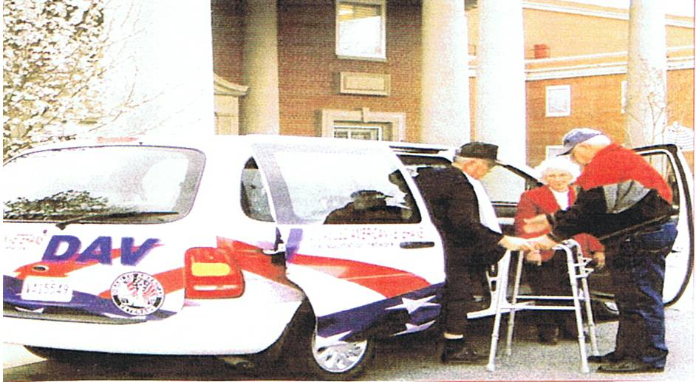

DAV, Dept of MD-Veteran of the Year
Chair – PDC Richard E. Bamberger

Chapter Commanders: The committee last two reports were submitted to you, the recommendation that the Chapter’s submit a Veteran of the Year recommendation. The Committee at this time has not received one recommendation for the Veteran of the Year 2008-2009. Comrades do not wait until the last minute. The DAV Department of MD has completed six months of this Election Year.
The committee recommended the Chapter Commanders appoint a Veteran of the Year Committee to submit a candidate’s name, address and phone number and a Biographical Statement of that candidate from your chapter. The Statement should list the candidate Military Service, what they have done since they became a member of the DAV what offices they held as DAV Members (National/Department/Chapter levels), and other Military Organizations accomplishments, Service Programs with any Special Citations the veteran has received. If you need assistance please contact any member of the committee.

The Members of this Committee wish you all a Merry Christmas and a Happy New Year. Comrades do not forget our Military Forces over these Holidays here at home and in harms way. God Bless our troops and God Bless America.

Chairman: PDC Richard E. Bamberger
2209 Pinefield Ct.
Waldorf MD 20601
1(301)645-1971
Fax (301)645-1971
E-Mail reddiver@verizon.net

Disabled American Veterans Auxiliary
Betty Swift, State Commander

There is a lot going on but I have nothing new to report. I did attend along with Adjutant Carol Simmons the “Welcome Home” program at Ripkin Stadium in Aberdeen on November 10, 2007, it was a cold and windy day but the returning Veterans were warm and friendly. It was an honor to greet them and I would do it again if and when the occasion should arise.

I am looking forward to the Mid-Winter DEC/SEC Meeting. It is to be held at the Princess Royale Hotel in Ocean City, MD on January 10-12, 2008. Make your reservations now if you plan to attend.

I wish all of you a Merry Christmas and a Happy New Year. I will be seeing most of you when I attend your Holiday affairs and I thank you in advance for inviting me.

Yours in Comradeship

Betty Swift
DAVA, State Commander

DAVA



National Service Office
Baltimore, Maryland

Greetings Comrades!

Happy Holidays to all and to your families.

I have the pleasure of informing the State that we have a new NSO trainee, Lamarr Couser. Because of one NSO leaving the DAV, we now have two trained NSO’s and one trainee in the Baltimore Office. I thank you in advance for your patience when trying to contact an NSO for assistance by way of a phone call.

Since my last letter, I have seen an increase in calls from our CSO’s getting advice, or just calling to make sure they understood something concerning VA benefits. We have had a good response for our CSO training that will be held on December 1st. By moving the training date to a new month, it frees up time for everyone to participate in our Mid-Winter Conference and State Convention. I look forward to seeing you CSO/DSO’s December 1st!

I would like to express my thanks to all who volunteered to assist us as we worked the DAV MSO van. We had great turnouts at the Harley Davidson events, and we had no problems. We even had National Commander Reynolds come out to one event! We met many people who had never put a claim in for service connection with the VA, and sadly enough a few that did not know it was available to do so. Well, at least they are on the right track now!

I would like to acknowledge CSO Robert Boles, from Chapter 26. He volunteered to spend a day with us in Baltimore, so he could help, and learn. He saw how we do business, and all the different responsibilities we have as NSO’s. He helped with answering the phones, interviews, etc. I do believe that he walked away from the office that day a lil’ bit wiser and informed. Thank you Robert, from the NSO Office.

Mobil Service Office

None scheduled at this time.

If you already are working with the DAV, National Service Office, it is better to call the DAV, NSO Office at 410-230-4440. The MSO truck is out there to meet new people and will not be able to check on a claim or anything for those who already have pending claims.

Happy Holidays from our Office,

Assistant Supervisor NSO Ron Minter, NSO Lamarr Couser, Support Staff Lenore Blackston, Denise Duckett, and myself.

Flip Micocci
NSO Supervisor, Baltimore

VETERAN’S DAY
AT
GOLDEN CORRAL

GLEN BURNIE, CHAPTER # 13
Golden Corral Mgr: Ms. Pat
Dept. Cmdr. Glynn E. Parker
Comrade Billie Miles, Chapter #13

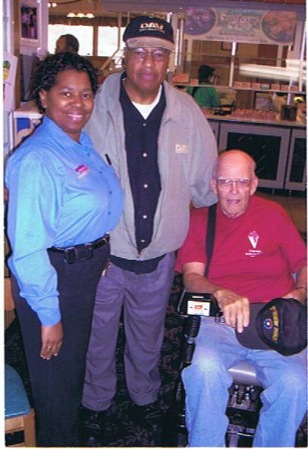
DAV, Department Admin Asst. (Cookie)
B. Iafolla - Helping at Golden Corral –
Glen Burnie, Chapter # 13

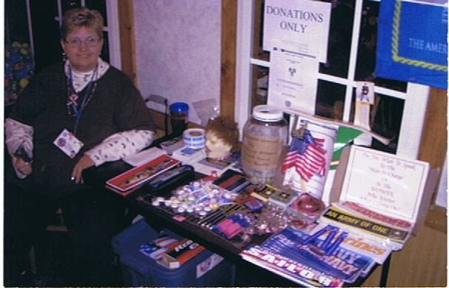

TOWSON, CHAPTER # 18
Forget-Me-Not Campaign
Chapter Adj. John H. Alexander
DAVA State Cmdr. Betty Swift
Golden Corral Mgr.
Deputy Secretary of Veterans Affair
Wilbert B. Forbes Sr. (PDC DAV Chapter #17)

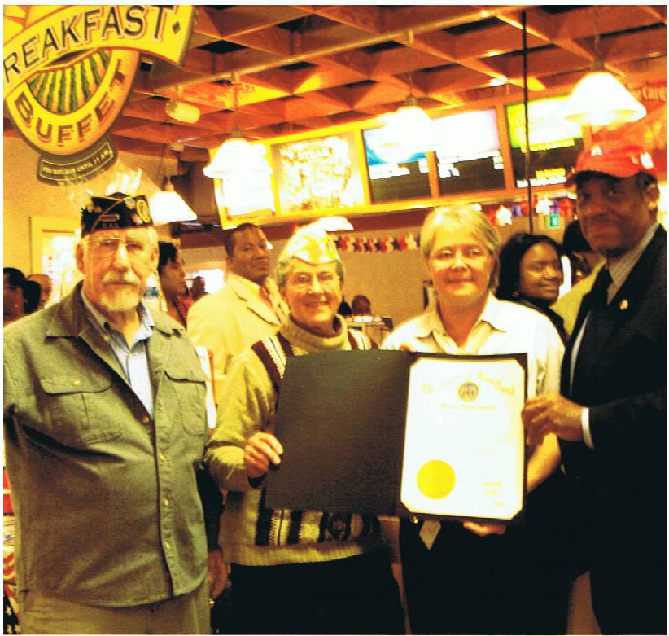

M.R. “SARGE” Warehime, CHAPTER # 33
Chapter Commander Hugh M. Ferguson, Jr.
presented a plaque to Golden Corral Manager: Tom Taylor and Co-Worker, along with Chapter Comrade Jim White.

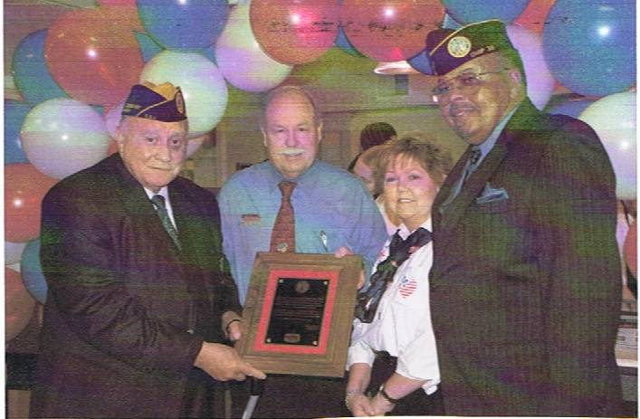

Young Marine Corps at Golden Corral

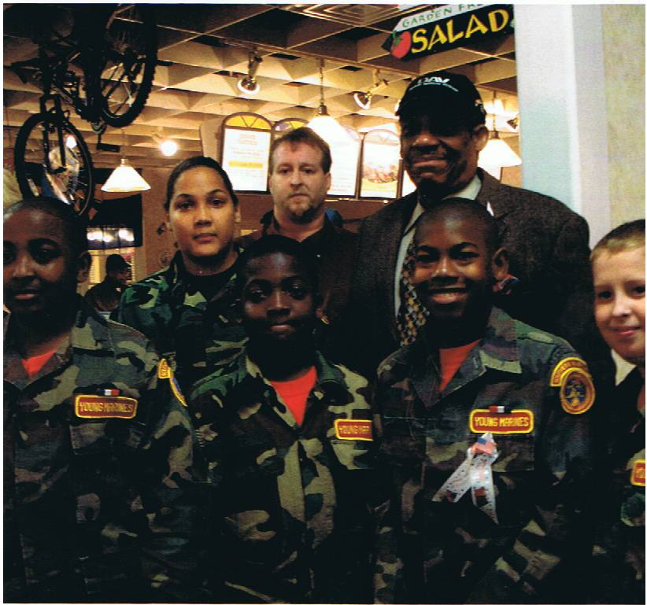

Deputy Secretary of Veterans Affairs, Wilbert B. Forbes Sr. (DAV, Chapter 17), with some Young Marines and Golden Corral managers at Golden Corral.

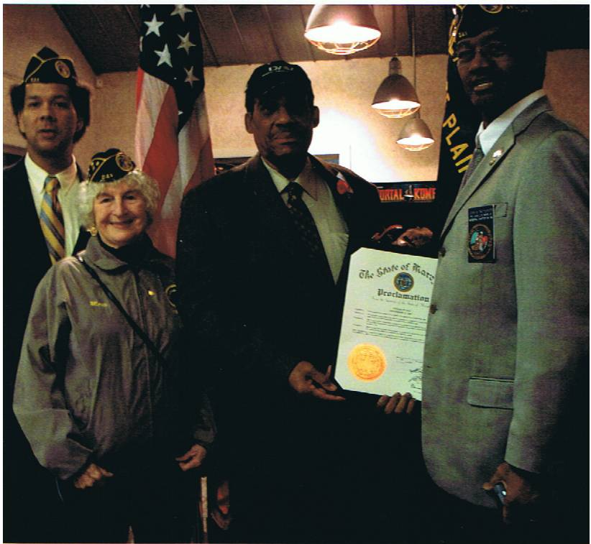

PFC John C. DeMarr Jr. Chapter #36
Forget – Me- Not Campaign
SVC Troy Garner
Comrade Marie Halter
Deputy Secretary of Veterans Affairs, Wilbert B. Forbes Sr. (PDC DAV, Chapter 17)
Chapter Commander John B. Patterson
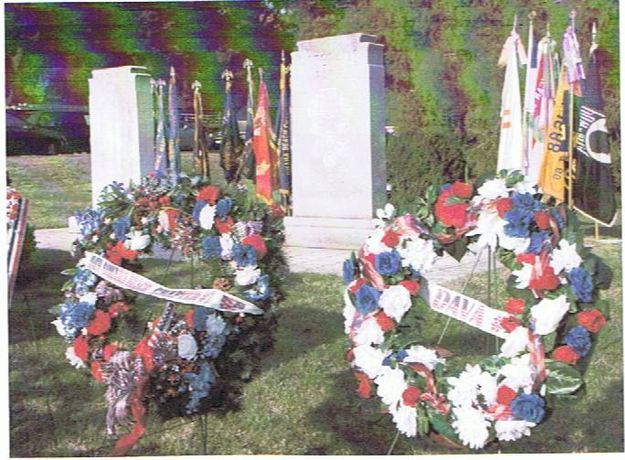

Omaha Beach Chapter 7 in Bowie,
hosted the Annual Veterans Day Ceremony at Bowie Veterans Park. The Chapter and the Unit placed wreaths in honor of all Veterans in the area.

A SPECIAL THANKS TO ALL GOLDEN CORRAL EMPLOYEES, DAV MEMBERS AND OTHERS WHO HONORED ALL VETERANS (PAST, PRESENT AND THOSE WHO ARE DECEASED) ON VETERANS DAY.

READ ALL ABOUT IT…

BAYSIDE AT FORT HOWARD

While all seniors have the opportunity to live in the community of Bayside, special emphasis is placed on serving those who have worked and fought to maintain our country’s freedom. Located on the historic Fort Howard campus, Bayside will offer a diverse selection of residence choices, lifestyle options, services, health care, and amenities, as well as a wide range of educational, cultural, and recreational activities. Planned in three phases, with the final phase scheduled for completion in 2012, it is anticipated that the first units will open in early 2008.

If you know a veteran or the widow/widower of a veteran who might be interested in living a Bayside, please let them know that an application package can be requested through any of the following methods:

- Call the Bayside at Fort Howard Customer Service Message Line at 1-866-698-9731
- Access the Bayside at Fort Howard website at www.baysidefthoward.com and complete the form under the “Contact Us” link
- Email the Bayside Customer Response Team at info@baysidefthoward.com

Alternatively, the application package can be downloaded directly from the Bayside at Ft. Howard website at www.baysidefthoward.com.

Volunteers Are Needed For the
“Help Hospitalized Veterans” Program

Distributing Crafts to the Hospitalized Veterans – Volunteers are needed at your choice of the below facilities

Monday – BRECC
Tuesday - Baltimore VA
Wednesday – Baltimore VA

The “HELP HOSPITALIZED VETERANS” program was established in 1971 for the purpose of serving hospitalized Veterans by providing Therapeutic Arts & Crafts and other services to our Nation’s Veterans and Military Community. The objective is to involve arts and crafts activity in the overall treatment plan for Veterans. The arts and crafts program improves the self esteem while improving the Veterans morale and physical motor skills. What a better and fun way to say “THANK YOU” to our Veterans!

Please contact: Sandi Kriebel,
Craft Care Specialist
Help Hospitalized Veterans
410-750-3941

Make a Difference, Right Now

You can make a difference in the lives of veterans and their families by volunteering at a VA Hospital or nursing home, right now. The smile you bring to the face of an elderly veteran or the encouragement you share with a hospitalized veteran’s loved ones is only made possible if you decide to volunteer.

There are various ways to volunteer, speak with the DAV VA Voluntary Service (VAVS) Representative, or VAVS Chief or other VAVS Staff members at VA Medical facility or Nursing Homes to find out how to get started volunteering. You can volunteer through the DAV Web site (www.dav.org), click on Volunteer or use the VA Web site at http://www1.va.gov/volunteer/.

PLEASE DECIDE TO VOLUNTEER…

Local Veterans Assistance Program (LVAP)

This is a program set up by the National Director of Voluntary Services at National Headquarters.

The LVAP allows volunteers to provide needed services to veterans and their families in their local community and be recognized for that service. LVAP volunteers will receive the same incentive awards as enjoyed by the volunteers in the VAVS program.

The DAV, Department Adjutant Lisa M. Gregory has the responsibility to report to National online web, the Chapters report of volunteer’s time for the activities of volunteers in their state on a monthly basis. LVAP volunteers may report volunteer time for a variety of activities which include, but are not limited to:

- Chapter and Department Service Office work.
- DAV specific outreach efforts (DAV Air show Outreach Program, Harley’s Hero’s, National Guard mobilizations and demobilizations, etc.)
3. Fundraising efforts (Forget-Me-Not, Golden Corral and other approved fund raisers.)
4. Direct assistance to veterans, widows, or families (yard work, home repairs, grocery shopping, etc.)

Chapters are to report the information needed to the Department Adjutant by the 5th of each month. The information that you should report to the Department Adjutant is listed below, it is important to provide all of the information so we can accurately identify and recognize each volunteer.

- Volunteers name
- Last 4 digits of their social security number
- mailing address
- telephone number
- total number of volunteer hours for the month
- type of activity

Youth volunteers who serve in the LVAP will also be eligible to apply for a scholarship through the Jesse Brown Memorial Youth Scholarship Program so long as they meet the minimum eligibility requirements for consideration.

We want those who volunteer their services to veterans and their families to get the recognition they deserve, so please take advantage of the Local Veterans Assistance Program (LVAP).

DAV Commander Thom Unkle, (Chapter 13,Glen Burnie, MD), who is chairman of the United Veterans of Anne Arundel County, spoke at a Veterans Day ceremony at Maryland Veterans Cemetery in Crownsville.

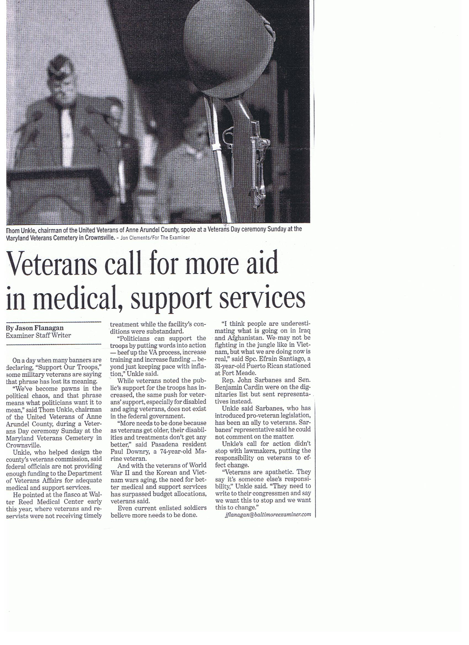

ENJOYABLE TIDBITS:

A Laugh a day; helps keep those Blues away……….

The Christmas Flight

t was a few days before Christmas. The trip went reasonably well, and he was ready to go back home. The airport on the other end had turned a tacky red and green, and loudspeakers blared annoying elevator renditions of cherished Christmas carols.
Being someone who took Christmas very seriously, and being slightly tired, he was not in a particularly good mood. (Almost a scrooge) Going to check in his luggage (which, for some reason, had become one suitcase with entirely new clothes), he saw hanging mistletoe. Not real mistletoe, but very cheap plastic with red paint on some of the rounder parts and green paint on some of the flatter and pointer parts, that could be taken for mistletoe only in a very Picasso sort of way.
With a considerable degree of irritation and nowhere else to vent it, he said to the attendant, "Even if we were married, I would not want to kiss you under such a ghastly mockery of mistletoe."
"Sir, look more closely at where the mistletoe is."
"Ok, I see that it's above the luggage scale which is the place you'd have to step forward for a kiss."
"That's not why it's there."
"Ok, I give up. Why is it there?"
"It's there so you can kiss your luggage good-bye."



